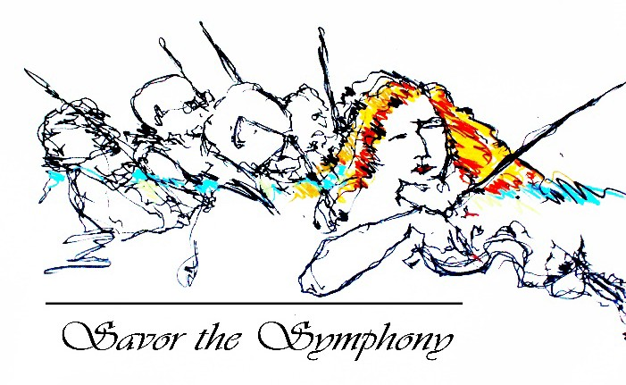

The Dallas Symphony Orchestra League presents
Savor the Symphony

Fact Sheet

Event Date: Thursday, April 29, 2021

Event Timeline: 6:30 p.m. Reception
7:00 p.m. Dinner
7:45 p.m Program

Event Description: Savor the Symphony will be a hybrid event. Ticket holders can enjoy the event in person at the Ritz-Carlton or they can opt to have their three-course dinner delivered to their home and have the event program streamed directly to them the evening of.

Location: The Ritz-Carlton, Dallas
2121 McKinney Ave
Dallas, TX 75201 Or
The ticketholder’s home

Honorary Chair: Roberta Corbett Event Chair: Sharon Ballew
DSOL President: Anne Ligon
Event Advisors: Barbara Bigham, Carole Ann Brown, Mari Epperson, Renee Farren, Jill Goldberg, Bettina Hennessy, Venise Stuart

Program: More information to follow

Benefit: Proceeds will benefit the outreach and education programs of the Dallas Symphony Orchestra.

